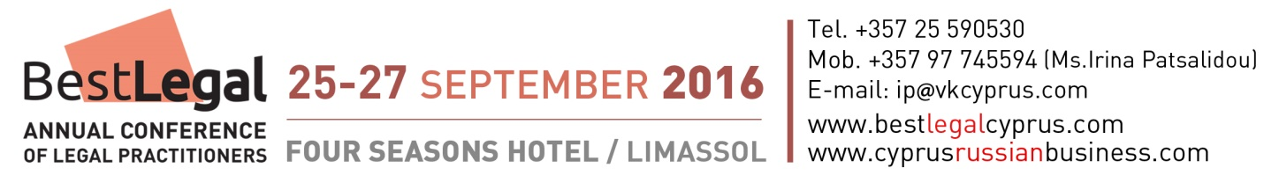

With support of Cyprus Presidency, Parliament of Cyprus, Cyprus Chamber of Commerce and Industry, Cyprus Investment Promotion Agency.

PROGRAM OF 3rd INTERNATIONAL ANNUAL CONFERENCE BEST LEGAL

Sunday, 25 September

00.00-18.00 Arrival of participants and guests of honor, free time.
The Organisers will meet participants at Larnaca and Paphos airports. Free transport will be provided to the hotels in Limassol.

20:00 Welcome Reception hosted by the Cyprus Investment Promotion Agency (CIPA). Address by Mr. Christodoulos Angastiniotis, President of CIPA and Mrs. Natalia Kardash, President of Best Legal Conference Organising Committee.

Monday, 26 September

08:15 – 08:45 Registration / Morning Coffee. Four Seasons Hotel Ballroom.

08.45 – 09.00 Morning introductions and networking discussions.

09:00 – 09:15 Official Opening Ceremony. Official Guests’ Welcome Addresses.

09:15 – 10:30 Plenary Session 1.

10:30 – 11:00 Networking coffee/tea break.

11:00 – 12:30 Panel discussions.

12:30 – 12:45 Networking break for informal exchange of opinions.

12.45 – 14.00 Plenary Session. Panel Discussion with VIP guests.

Topics of the Conference include:
- 2015-2016 Cyprus tax changes (notional interest deduction, non-domiciled exemption for SDC, income tax exemptions for new taxpayers etc);
- Regulatory and information exchange issues and security of investments. The measures that have been introduced in Cyprus and EU and what changes are due in 2017 and 2018.
- Protection of personal data. Changes after “Panama papers” case.
- Legal methods of protecting the interests of investors in Cyprus and European Union. Private wealth planning and legal protection strategies.
- Litigation in Europe: Procedures, remedies, best practice and trends. Practical examples of the interplay between EU and national law will be provided, with a specific case study on the case of a "haircut" of deposits submitted by Cypriot lawyers in European courts.
- Regulatory sphere in Cyprus. The positive changes and problematic issues.
- International PR and promotion of a legal office. Creation of a marketing plan for promoting legal services in foreign markets.

14:00 – 15:00 Networking Lunch in the Four Seasons Hotel

15:00 – 16:30 Plenary Session «Regulations of investment immigration industry. Educational session for practitioners». Speakers from International Migration Council.

17:00 – 19:30 Seminar “De-offshorisation in Russia and its influence to Cyprus and European Union”. Latest news, decisions, regulations and laws presented by Russian experts.

Tuesday, 27 September

09:00-13.30 Business trip to Nicosia for foreign guests. Visit to the Parliament of Cyprus. Visit to the Presidential Palace.

16.00-19.00 Seminar on marketing of a legal firm
(Optional. Free for conference participants, 65 euro for others)

New methods of online promotion of legal services in foreign markets
- Creation of a marketing plan for promoting legal service in foreign markets.
- How to direct potential customers that are looking for legal services to your website.
- What are the keywords that potential customers use when they search for legal services in Cyprus.
- How to attract potential customers from Google search.
- How the law offices in Cyprus and abroad can turn their websites into sales generator.
- How you can promote your services for free in other countries.
- The correct use of Facebook for Law offices. Creation of a professional Facebook page for law offices.
- The correct use of LinkedIn for lawyers. Creation of a professional LinkedIn profile for lawyers.
- The correct use of Google+ for Lawyers. Creation of a professional Google+ page.

Wednesday, 28 September
Departure day. Free group transfers to Larnaca and Paphos airports.

Organisers: SUCCESSFUL BUSINESS Magazine
Additional Information:
www.bestcyprusbusiness.com
Tel. +357 25590530 (from 9.00 to 17.00), +357 97 745594 (any time)
registration forms:
ip@vkcyprus.com (event coordinator Ms. Irina Patsalidou)

