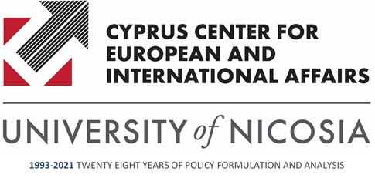

The School of Law and the Cyprus Center for European and International Affairs of the University of Nicosia

would like to invite you to the

ONLINE Research Seminar

THE FRAMEWORK OF JUDICIAL COOPERATION AFTER BREXIT – CIVIL AND COMMERCIAL MATTERS

By

Dr Konstantinos D. Voulgarakis
Adjunct Lecturer, School of Law, University of Nicosia
Post-doctoral Research Fellow, School of Law, Aristotle University of Thessaloniki

Wednesday, 12 May 2021
11:30 – 13:00

Chair: Dr Andreas Kirlappos, Part-time Faculty and Research Associate
University of Nicosia

Abstract

The presentation will provide an overview of the key legal issues affecting civil justice and judicial co-operation arising from the UK's exit from the EU. It will explain how the UK's withdrawal is likely to impact on the framework of rules which apply in this area and, in particular, the rules relating to jurisdiction, enforcement of judgments and governing law. The key questions to be addressed will revolve around (i) the effect of the EU/UK Withdrawal Agreement in the field of judicial cooperation, (ii) pending procedures in the UK and/or EU Member States, (iii) the recognition of judgments rendered in EU Member States and/or the UK and (iv) choice of law clauses and the extent to which such clauses may be upheld by UK and/or EU Member State courts.

*R.S.V.P. until May 11, 12:00 noon by e-mail: cceia@unic.ac.cy
**Zoom link: https://us02web.zoom.us/j/85472207974

