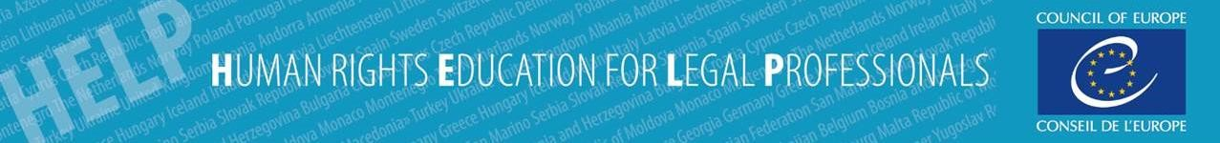

Self-learning online course on the
New Civil Procedure Rules in Cyprus for Lawyers
This self-learning online course provides information about the new Cypriot Civil Procedure Rules (CPR). It is expected to become a useful tool for all legal professionals, providing access to information about the philosophy of the new CPR and the novelties in the civil procedure. The course has three (3) main Modules.
Module 1 "New Civil Procedure Rules": provides an introduction and analysis of some of the most important changes in the civil procedure. It describes Parts 1, 3, 28-30, 31, 34, 35 and 39 of the Rules.
Module 2 "Illustrating case law of England and Wales": guides through existing English and Welsh case law corresponding to the respective Parts of the Rules analysed in Module 1.
Module 3 "Fair Trial standards in case law of the European Court of Human Rights (ECtHR)": describes the main principles applied by the ECtHR and explores various provisions of the new Rules in relation to Article 6 of the European Convention on Human Rights (right to fair trial).
The users can follow the course at their free time and at their own pace. The Modules are presented in a practical manner and include videos, reading material with links to the relevant cases, case studies and knowledge tests (quizzes). These quizzes shall allow assessment of the acquired knowledge of the presented material. The users who successfully complete the course will automatically receive a statement of accomplishment.

Target audience
This free on-line course is addressed to Cypriot lawyers, legal officers, trainees and law students.

Course outline
- Course Overview and Technical Assistance
- Introduction to the CPR Reform
- Module 1: New Civil Procedure Rules
- Module 2: Illustrating case law of the England and Wales
- Module 3: Fair Trial standards in the case law of the European Court of Human Rights
- Final Quiz and Course Evaluation
- Extra Resources and Materials

Access the free online course
The course is hosted on the HELP e-learning platform. To access the course, you will need to 1. create a HELP account if you do not already have one, which only takes 2 minutes, by clicking here and then 2. follow this link to find the course and enrol. For details on how to create a HELP account you can watch this video: vimeo.com/399804233
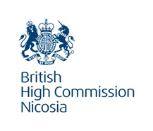
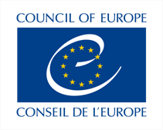
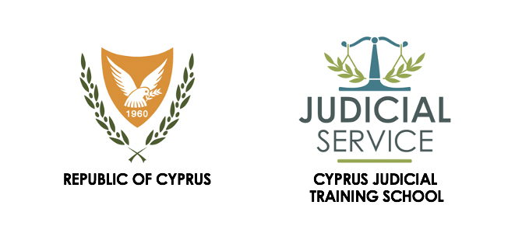The development of the course was funded by the Foreign Commonwealth and Development Office of the United Kingdom and implemented by the Council of Europe in collaboration with the Cyprus Judicial Training School and the Cyprus Bar Association.

